Assignment-02

[30]:

**import**

**numpy**

**as**

**np**

**import**

**pandas**

**as**

**pd**

**import**

**matplotlib**

**.**

**pyplot**

**as**

**plt**

**import**

**seaborn**

**as**

**sns**

[31]:

data

=

sns

.

load_dataset(

'

car_crashes

'

)

[32]:

data

.

head()

[32]: total speeding alcohol not_distracted no_previous ins_premium \

0 18.8 7.332 5.640 18.048 15.040 784.55 1 18.1 7.421 4.525 16.290 17.014 1053.48

1. 18.6 6.510 5.208 15.624 17.856 899.47
2. 22.4 4.032 5.824 21.056 21.280 827.34
3. 12.0 4.200 3.360 10.920 10.680 878.41

ins_losses abbrev

1. 145.08 AL
2. 133.93 AK
3. 110.35 AZ
4. 142.39 AR
5. 165.63 CA

[33]:

data

.

info()

<class 'pandas.core.frame.DataFrame'>

RangeIndex: 51 entries, 0 to 50 Data columns (total 8 columns):

# Column Non-Null Count Dtype

--- ------ -------------- ----0 total 51 non-null float64

1. speeding 51 non-null float64
2. alcohol 51 non-null float64
3. not_distracted 51 non-null float64
4. no_previous 51 non-null float64
5. ins_premium 51 non-null float64 6 ins_losses 51 non-null float64

7 abbrev 51 non-null object

dtypes: float64(7), object(1) memory usage: 3.3+ KB

we can plot the number of drivers involved in fatal collision(total) against the percentage of drivers who were speeding(speeding).

[34]: *'''inference: the scatter plot below suggests that there is a positive*␣ ↪*correlation between the number of drivers involved in fatal collisions and*␣ ↪*the percentage of drivers who were speeding.*

*This means that states with higher speeding rates tend to have more fatal*␣ ↪*collisions. '''* sns.scatterplot(x = 'total', y = 'speeding', data = data)

[34]: <Axes: xlabel='total', ylabel='speeding'>

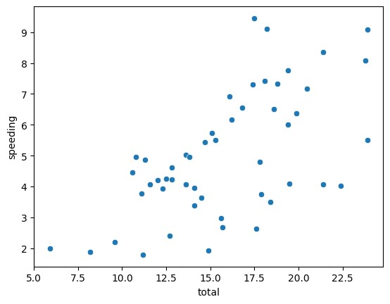

[35]: *''' Inference: the percentage of drivers who were alcohol-impaired varies*␣ ↪*significantly from state to state.*

*This suggests that alcohol-impaired driving is a major factor in fatal*␣ ↪*collisions in some states, but not others.'''* plt.figure(figsize=(12,6))

sns.barplot(x = 'abbrev', y = 'alcohol', data = data)

[35]: <Axes: xlabel='abbrev', ylabel='alcohol'>

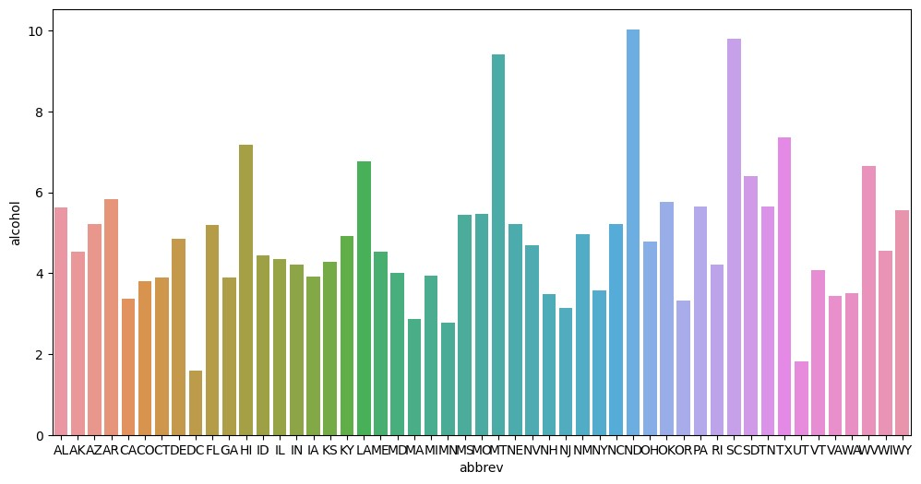

[36]: *''' Inference: the majority of drivers involved in fatal collisions were not*␣ ↪*distracted.*

*This suggests that distracted driving is not the leading cause of fatal*␣ ↪*collisions.'''*

plt.figure(figsize=(12, 12)) plt.pie(data['not_distracted'], autopct='**%1.1f%%**') plt.show()

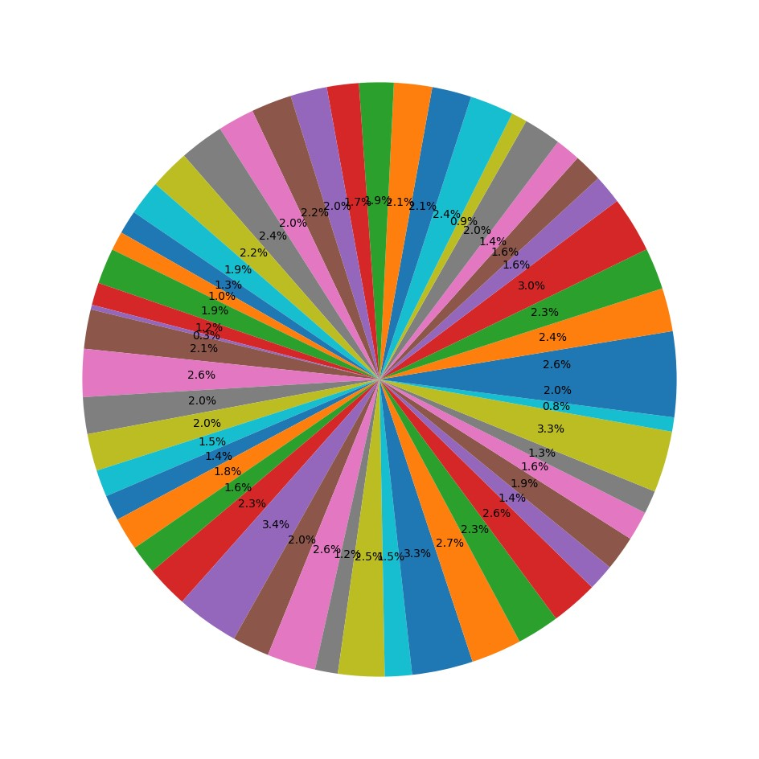

[37]:

sns

.

distplot(data[

'

total

'

])

C:\Users\sivar\AppData\Local\Temp\ipykernel_4884\3477427589.py:1: UserWarning:

`distplot` is a deprecated function and will be removed in seaborn v0.14.0.

Please adapt your code to use either `displot` (a figure-level function with similar flexibility) or `histplot` (an axes-level function for histograms).

For a guide to updating your code to use the new functions, please see https://gist.github.com/mwaskom/de44147ed2974457ad6372750bbe5751 sns.distplot(data['total'])

[37]: <Axes: xlabel='total', ylabel='Density'>

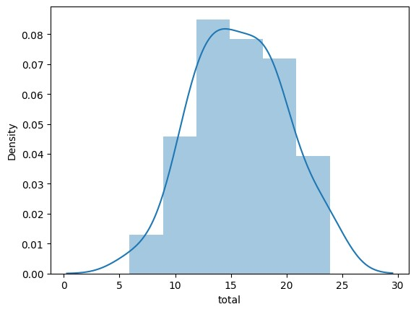

Below plots are relation between every two variables in the dataset

[38]:

sns

.

pairplot(data)

c:\Users\sivar\AppData\Local\Programs\Python\Python311\Lib\sitepackages\seaborn\axisgrid.py:118: UserWarning: The figure layout has changed to tight

self._figure.tight_layout(*args, **kwargs)

[38]: <seaborn.axisgrid.PairGrid at 0x17f74068610>

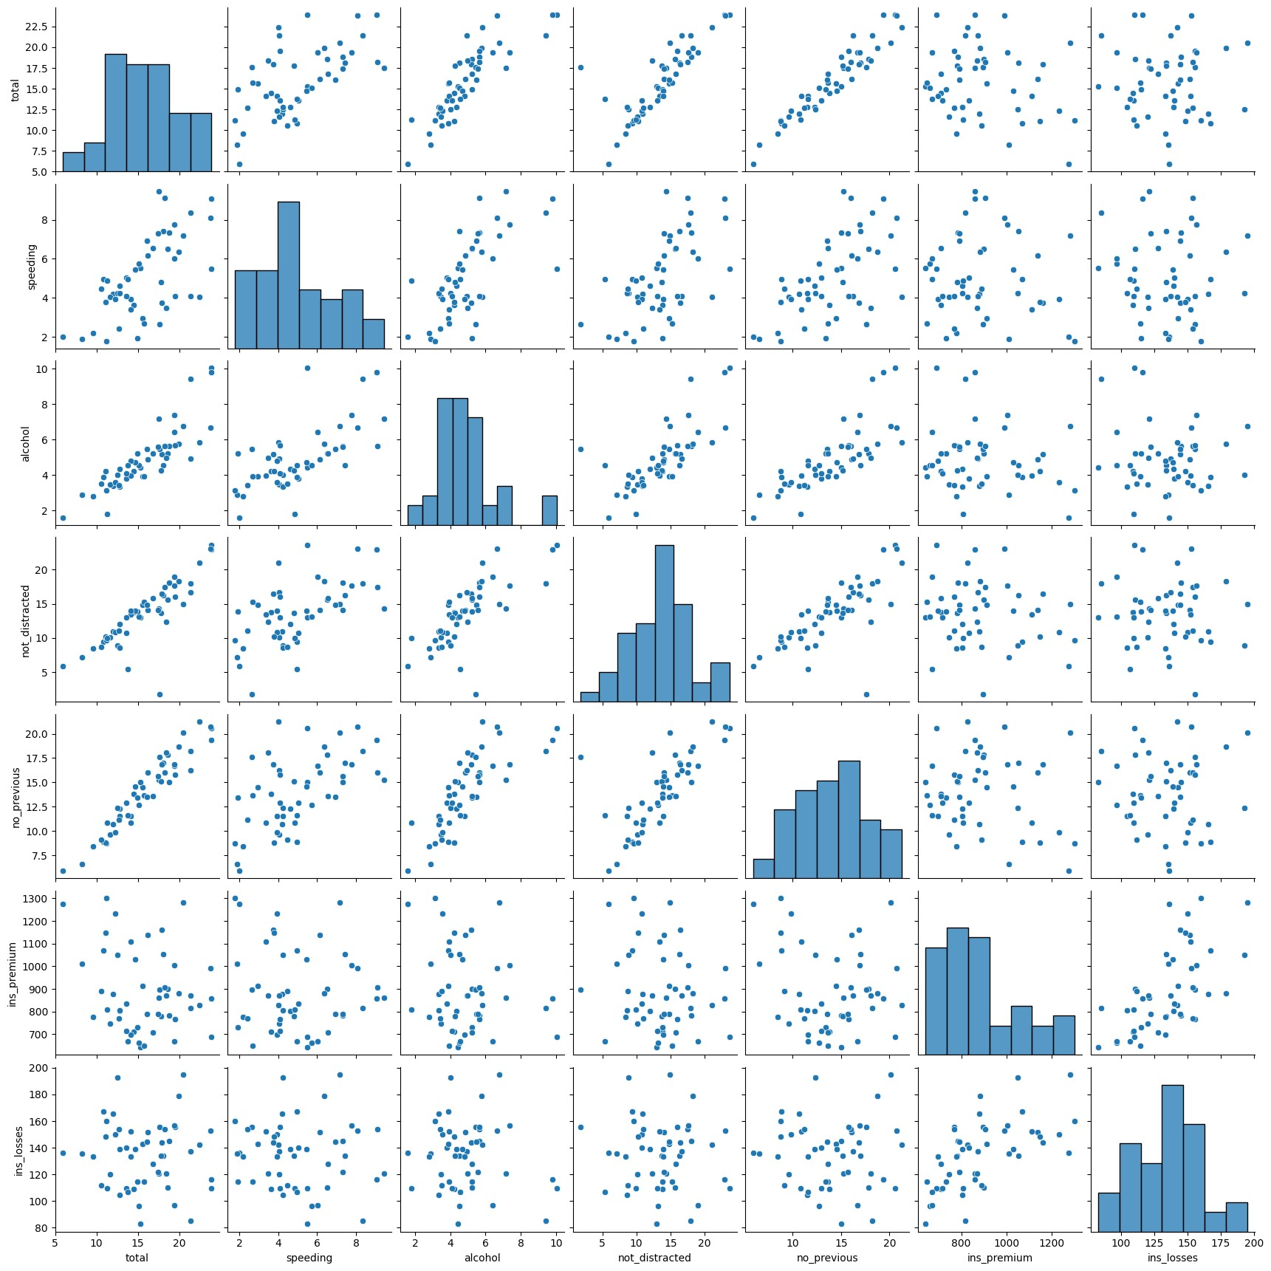

DONE BY : CHANUBOYANA SIVANANDA (21BCE9421)